
Invoice To:
Russly Bruce Interior Concultant Los Angeles, USA
INVOICE
Invoice Number : 22FHJ30L02TNF2
Qty
Total
Task Description
Price
1
Furniture
$2.000.000
$2.000.000
Design Conculting
$3.000.000
1
$3.000.000
Accomodation
$100.000
5
$500.000
Pool & Bar
$4.000.000
1
$4.000.000
Note:
Fusce id velit ut tortor pretium viverra tortor Pretium nibh ipsum consequat nisl velocitya velit ut tolekisho Fusce id velit ut tortor pretium viverra.
+00 123 456 789
yourmail@domain.com
246 Coolidge Street, CA

Date:
07/12/2021 Subtotal $86.00
Tax $10.00
Bank / Paypal Info
info@yourcompany.com Total $9.500.000
Account Number 5407 3249 31

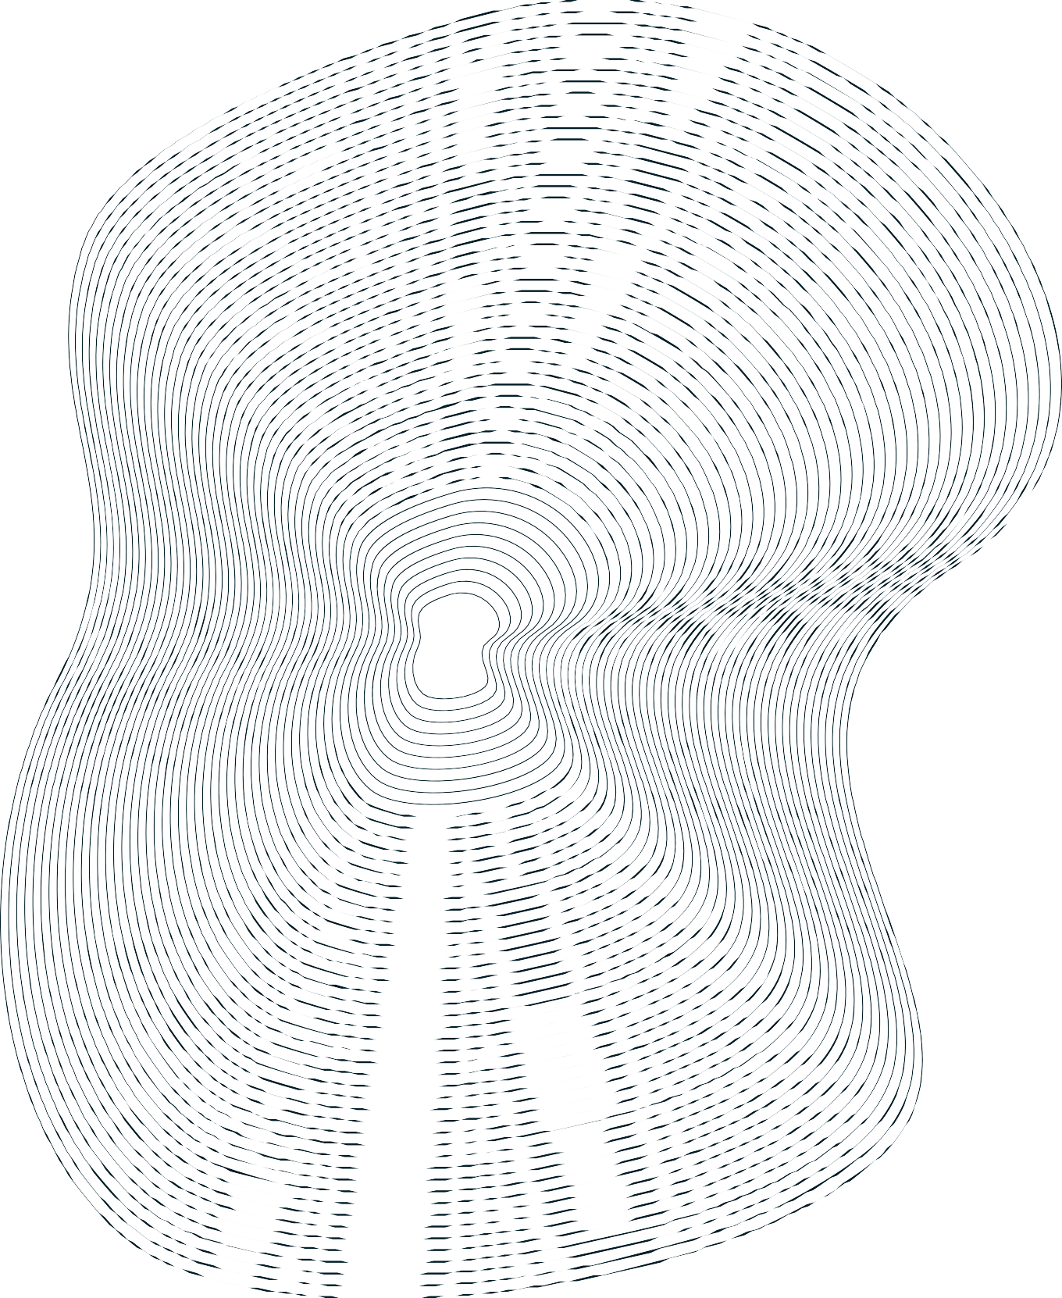
Invoice To:
Russly Bruce Interior Concultant Los Angeles, USA
INVOICE
Invoice Number : 22FHJ30L02TNF2
Qty
Total
Task Description
Price
1
Furniture
$2.000.000
$2.000.000
Design Conculting
$3.000.000
1
$3.000.000
Accomodation
$100.000
5
$500.000
Pool & Bar
$4.000.000
1
$4.000.000
Note:
Fusce id velit ut tortor pretium viverra tortor Pretium nibh ipsum consequat nisl velocitya velit ut tolekisho Fusce id velit ut tortor pretium viverra.
+00 123 456 789
yourmail@domain.com
246 Coolidge Street, CA

Date:
07/12/2021 Subtotal $86.00
Tax $10.00
Bank / Paypal Info
info@yourcompany.com Total $9.500.000
Account Number 5407 3249 31

